Towards a predictive model of species interaction betadiversity

MS submitted to Ecology Letters in the “Perspective” category.

Catherine H. Graham1^* and Ben G. Weinstein2^

1Swiss Federal Research Institute (WSL), Birmensdorf, Zurich. [catherine.graham@wsl.ch](mailto:catherine.graham@wsl.ch)

2Department of Fisheries and Wildlife, Marine Mammal Institute, Oregon State University, 2030 Marine Science Drive, Newport, OR 97365, USA. weinsteb@oregonstate.edu

*Corresponding author

^ authors contributed equally to this work.

Running Title: Interaction beta-diversity

Keywords: Bayesian, evolutionary history, interaction beta-diversity, rewiring, scale, turnover

Abstract Length: 123

Main Text Length: 4010

Number of References: 85

Number of Figures: 4

Number of Boxes: 1

Authorship: CG, BW developed the conceptual ideas and wrote the MS.

Data Accessibility: Should the manuscript be accepted, we will place all data in DRYAD for archiving.

# ABSTRACT

Species interactions are fundamental to community dynamics and ecosystem processes. Despite significant progress in describing the connections among species, we lack a comprehensive view of when interactions should change across time and space. By focusing on interaction beta-diversity, which considers both spatial and temporal species turnover and the change in the intensity of interactions, we can connect changes in local interactions with regional biodiversity. Here we discuss the biological insights and methodological concepts surrounding interaction beta-diversity, as well as outline a Bayesian approach to predicting species interaction intensity based on the biotic and abiotic environment. Integrating statistical models of local interactions with biogeographic and evolutionary histories of co-occurring species will provide new insight into the mechanisms that drive variation in patterns of biodiversity.

# INTRODUCTION

Patterns of species diversity are caused by multiple ecological, evolutionary and biogeographic processes acting across spatial, temporal and phylogenetic scales. Given this complexity, most attempts to explore the causes of ecological diversity focus on single trophic levels, ignoring the added complexity of species interactions. However, acknowledging that nature is interconnected and multiple species should be considered simultaneously, recent work has emphasized the spatial and temporal variation in species interactions (i.e., interaction beta-diversity, cite). Attempts to understand this variation have yielded a myriad of results. In some cases, interaction beta-diversity appears to be driven by species turnover, which depends largely on the environmental tolerances, phenology and dispersal ability of interacting partners (Trojelsgaard *et al.* 2015)(Miller-Struttmann & Galen 2014, Kemp *et al.* 2017). Alternatively, co-occurring species may interact differently over space and time (i.e., rewiring) as a result of changes in the benefits and costs associated with a given interaction (Bartomeus *et al.* 2016; Sazatornil *et al.* 2016). Given that distinct mechanisms, acting at different scales, lead to observed patterns of interaction beta-diversity (Mayfield & Levine 2010; Adler *et al.* 2013; Kraft *et al.* 2014), it has been challenging to develop models that embrace this complexity. Further, despite significant methodological advances (cite), we lack a conceptual and statistical tool box to rigorously predict spatial and temporal variation in species interactions. Here we use ecological theory and hierarchical Bayesian models to develop a predictive model of species interactions, emphasizing mutualistic interactions. We explore this approach using a five-year time series of Ecuadorian hummingbirds and their food plants (Box 1).

**ELEMENTS OF A PREDICTIVE MODEL OF SPECIES INTERATIONS**

Our vision for modeling spatial and temporal variation in species interactions has three key inter-related elements: it is predictive, it focuses on modeling pairwise interactions and it explicitly incorporates sampling uncertainty. Several of these elements have been discussed in the literature, but it is the synthesis of all three aspects that makes our approach unique and timely. Further, we provide a worked example to help move the field from a somewhat theoretical focus to a more data driven endeavor to begin to assess the generality of network theory and the consistency of interaction data over time.

Our approach focuses on predicting the presence of species interactions in response to the biotic and abiotic environment, rather than exploring the fit of a model to the data used to estimate model parameters. By focusing on prediction, we can assess the generality of ecological mechanisms underlying species interactions. Solely relying on the fit of the model based on observed data risks making the assumption that because a given model best explains our observed interactions, it will generalize through space or time or to new taxa. Using prediction, we can explicitly test this assumption by assessing the predictive error using data withheld from model training.

Second, mechanisms governing interactions should be analyzed on a pairwise basis. The existence of an interaction is determined by the balance between the cost of searching for and interacting with a specific partner, and the benefit gained from this interaction (Spiesman & Gratton 2016; Valdovinos *et al.* 2016). The outcome of this balance leads to, often unmeasured, fitness benefits. That interactions are a product of adaptations of each partner species has long been established in the behavioral and evolutionary literature (cite) however, our emphasis on analyzing pairwise interactions (i.e., the probability of interaction links) is in contrast with some current attempts to quantify interaction beta-diversity. Perhaps the most common approach extends measures of compositional beta-diversity to evaluate the proportion of change in interactions explained by change in species composition or change in interactions (Novotny 2009; Poisot *et al.* 2012; Carstensen *et al.* 2014; CaraDonna *et al.* 2017). The limitations of this approach, and similar matrix-based analyses, is the overall focus on the observed matrix of interactions as static quantity without estimates of uncertainty or a mechanistic representation of why networks change over time and space (Olesen *et al.* 2008; Petanidou *et al.* 2008; Poisot 2016). The observed matrix of interactions is simply one realization of the potential networks that could have been observed due to sampling constraints and the spatial and temporal heterogeneity in the probability of species interactions (Poisot *et al.* 2015b). By analyzing pairwise interactions, we can assess the model fit of individual links, allowing us to explore the natural history of interacting partners, rather than assuming that all links in a network are best supported by a single ecological mechanism.

A final aspect of our approach is that it acknowledges that both the observation process, and the underlying ecology of species interactions, may result in changes in species interactions across space and time. To explore species interactions ecologists often use observations gathered through field surveys. However, when field sampling fails to find an interaction, is it unclear whether the sampling simply failed to detect the interaction, or if the interaction truly did not occur. The danger is in conflating non-detections with true absences, and mistakenly inferring spurious ecological mechanism. The probabilistic approach we propose explicitly considers this issue and therefore should yield a clearer understanding as to how spatial and temporal variation in sampling influences the probability of observing a given interaction.

**TOWARDS A PREDICTIVE MODEL OF INTERATION BETA-DIVERSITY**

Inspired by community assembly theory (Ackerly 2003; Marske *et al.* 2013) we explore how spatial and temporal variation in network structure is influenced by abiotic (elevation) and biotic (species identity, trait matching) factors (Fig. 1; Gravel *et al.* 2011; Carstensen *et al.* 2014). We build from recent developments in network ecology (Bartomeus *et al.* 2013; Gravel *et al.* 2013, 2016; Poisot *et al.* 2015a; Weinstein & Graham 2017a), to show how species interactions can be modeled as probability distributions in a hierarchical Bayesian framework (Wells & O’Hara 2013; Coblentz *et al.* 2017). Further, this approach allows us to estimate the uncertainty in species interactions, differentiate the predictors of interactions from the probability of detecting an interaction, and assess the variation in emergent network properties by generating many realizations of the network from the model posterior parameters.

Using the hummingbird-flower data as an example (Box 1), we test the predictive accuracy of a series of models with increasing complexity, starting from interactions as simple probabilistic events then adding detection probability, and environmental predictors of species co-occurrence. To evaluate the models, we split our hummingbird-flower time-series into training (75%) and testing data (25%) (Figure X). The aim is to minimize the error in predicting the test data with models built from the training data. For each model, we compute the accuracy (proportion of correctly predicted links in testing data), and the mean predictive error per species, and the overall network connectance. These three measures of model fit represent our ability to predict which interactions occur, which species are best predicted by a given model, and the higher order structure of the ecological community. We then use our approach to explore interaction beta-diversity by evaluating how interactions change across two distinct seasons in our system (Box 2). Finally, we extend this model of interaction betadiversity to include mechanistic models using trait-matching (Box 3).

**Modeling interactions as probabilistic events**

The simplest interaction model is a random encounter model, in which each species has equal probability of interacting with each partner species during each observation period. For example, for our hummingbird data (Box 1), the probability of observing a given species (*i)* visiting a partner species (*j*) filmed by a camera (*k*), on a filming day (*d*) is

$$Y_{i,j,k,d}∼Bernoulli(p=0.5)$$

The probability of a link would therefore be 1-(1/2)^n for n days of camera filming. This is a baseline model and provides a comparison for which to compare subsequent ecological models.

The next step is to replace the random encounter model with an interaction probability for each species pair. The parameter $p_{i,j}$ can be interpreted as the per camera filming day probability of interaction.

$$Y_{i,j,k,d}∼Bernoulli(p_{i,j})$$

## **Incorporating incomplete detection**

Due to incomplete sampling, it is not possible to detect all interactions which occur (Blüthgen 2010, Olesen et al. 2011). Incomplete and uneven sampling limits our ability to compare the frequency and predictors of interactions across networks (Chacoff *et al.* 2012; Frund et al. 2015 ). One way to address this issue is with null models where the observed interaction matrix is randomized with respect to the abundance of one or both partners (MacLeod *et al.* 2016); however, choosing the correct null model can be extremely difficult, especially when attempting to disentangle the multiple mechanisms shaping species interactions (Dormann *et al.* 2017). Alternatively, detection probability can be directly estimated using hierarchical N-mixture models (Royle, Bartomues). The true interaction state (0 or 1) between species *i* and partner species j is considered fixed at each camera k. Each day of filming is an attempt to recover this true state based on the detectability of one partner species ${(ω}_{i})$.

$$Y_{i,j,k,d}∼Bernoulli(S_{i,j,k}* z_{i,j,k})$$

$$z_{i,j,k}∼Bernoulli(ω_{i})$$

$$S_{i,j,k}∼Bernoulli(p_{i,j})$$

We take the simplest approach by modeling a fixed detection probability per species, which assumes that more abundant species are more likely to be detected in a given observation period. However, the differences in detectability among species interactions remains understudied and may depend on a variety of factors depending on the organisms being modeled, such as on species abundance, size, color, behavior, and movement (Weinstein & Graham 2017a; cite other). In hummingbirds, factors such as territoriality, and the frequency of replenishment of partner rewards can shape the likelihood of detecting an interaction given that it occurs. In our example system, the detectability of plants is considered fixed, since a camera is placed a single plant in frame. In other systems, the detectability of a given interaction may depend on the joint detectability of both the species and its partner, transforming $(ω_{i})$ into ($ω_{i,j})$.

## **Incorporating species occurrence**

To interact species must co-occur (Gravel). Therefore, observed absences of an interaction may stem from either our ability to detect interactions that occur, or because one partner species is not present. To model species co-occurrence, we need to model species presence based on the environmental during the sampling period. For example, in our hummingbird dataset, cameras captured interactions along a wide elevation gradient ranging from 1300 – 2500m. We can therefore model the probability of interactionas a function of the probability of occurrence of species *i* at the elevation of camera k ($ψ_{i,k}$), the probability of interaction between species *i* and partner species j ${(p}_{i,j})$, and the probability of detecting an interaction ($ω_{i}$), given that it occurs. The model can be extended to include other covariates or a probability of species presence based on a species distribution model.

$$Y_{i,j,k,d}∼Bernoulli(S_{i,j,k}* z_{i,j,k}*occ_{i,k})$$

$$z_{i,j,k}∼Bernoulli(ω_{i})$$

$$S_{i,j,k}∼Bernoulli(p_{i,j})$$

$${occ}_{i,k}\sim Bernoulli\left(ψ_{i,k}\right)$$

$$logit\left(ψ\right)=α_{i}+β_{i}*elevation_{k}$$

As with species detectability, our example system has a fixed probability of presence for the partner species (plants), since a camera is placed at an individual flower in bloom. In other sampling designs, such as line transects, the presence of both species can be modeled separately, such that the probability of interaction is conditional on the presence of both species. For example, in plant-pollinator studies, one could estimate the importance of phenology on the probability of interaction by adding a time-indexed covariate, such as Julian day, in shaping which flowers are in bloom.

$${occ}_{j,k}\sim Bernoulli\left(ψ_{j,k}\right)$$

$$logit\left(ψ_{j,k}\right)=α_{j}+β_{j}*julian_day_{k}$$

# Interaction Betadiversity

To investigate why species interactions change over time and space, we need to consider the mechanisms shaping interaction betadiversity. Interactions may change due to changes in 1) fitness benefits, 2) detectability, and 3) species co-occurrence. For each of these factors, we can alter our model to assess whether adding time-based indices improves prediction and highlight the interaction links that might change over time. However, before we begin, it is critical that we describe the meaning of stochasticity in our probabilistic model. The posterior distribution of the probability of interaction captures the variance in the ecological process given our available data. Whether this variance stems from unmeasured ecological variables, or the true ‘randomness’, is a matter of interpretation (Youngflesh). For our practical purposes, it means that the likelihood of observing an interaction on a given day of filming is variable. Rather than focusing on predicting individual observations, we are interested in the distribution that describes the probability of observing a given interaction link. This means that every sampling event will yield variation. We do not see this variation as a meaningful measure of ecological betadiversity, but rather as the outcome of a stochastic ecological process. Meaningful betadiversity will come from underlying changes in the ecological process. In our example, we can assess this by testing whether the addition of time-based indices to the observation and process models improve predictions of interactions in our testing data.

Changes in Fitness benefits

Species interactions can be broadly conceptualized as the outcome of the *quantity* of interactions and the fitness-based *quality* of a given interaction (Vázquez *et al.* 2015; Schupp *et al.* 2017). Changes in the costs of searching for a partner may reduce the quantity of interactions, and changes in the benefits from an interaction may influence the quality of interactions. These shifts in fitness benefits may be a function of the abiotic environment, such as increased foraging costs during a warmer season, or due to the biotic environment, such as the seasonal presence of competitors. For example, Magrach *et al.* (2017) found that seasonal pulses in honeybee abundance resulted in competing native bee species using fewer plant species in agricultural landscapes.

Given that there are marked seasons in our system (Box 1) we chose to assess temporal changes in the probability of species interactions by replacing the probability of interaction $p_{i,j}$ with a function of species identity and season during observation period k. From this we can estimate the effect of season on the temporal change in interactions $β_{i,j}$, which is better known as temporal rewiring. This approach allows us to directly estimate rewiring while accounting for species occurrence and species detectability.

$$S_{i,j,k}∼Bernoulli(p_{i,j,k})$$

$$logit\left(p_{i,j,k}\right)=α_{i,j}+β_{i,j}*season_{k}$$

Changes in Detectability

While the ecological mechanisms underling

$$z_{i,j,k}∼Bernoulli(ω_{i})$$

$$logit\left(ω_{i}\right)=α_{i}+β_{i}*season_{k}$$

Changes in Occurrence

As the abundance of co-occurring species decreases, the cost for searching for specific partners increases, due to lower encounter rates. This may result in rewiring if the benefit from partner fidelity is outweighed by the higher cost of searching for a specific partner. Species turnover occurs when the abundance of the species goes to zero. We can assess the probability of occurrence as an interaction between environment and a fixed time period, such as season.

$${occ}_{i,k}\sim Bernoulli\left(ψ_{i,k}\right)$$

$logit\left(ψ_{i,k}\right)=α_{i}+β_{i}^{'}*elevation_{k }+ β_{i}^{''}*{season}_{k}+β_{i}^{'''}*elevation_{k}* {season}_{k}$

The key parameter is here $β_{i}^{'''}$ which reflects the effect of season on changes in the probability of occurrence of species i and thus captures beta-diversity

**Incorporating traits**

In the examples outlined above, we use testing data to evaluate how well our model to predicted temporal changes in species interactions. However, by relying on species identity to estimate the probability of interaction, we limit our ability to predict to novel systems with new species. Species identity is useful, since it captures the entire multi-dimensional niche without needing to specify a specific formal relationship between covariates. However, species identity does not directly allow us to investigate interaction betadiversity when there is a new set of species. One approach to resolve this issue is to use functional traits as a proxy for the fitness benefits incurred by one or both interaction partners (Stang *et al.* 2009; Bartomeus *et al.* 2016). Trait-matching, which has been well documented across many interacting organisms (e.g., Santamaría & Rodríguez-Gironés 2007; Maglianesi *et al.* 2014b; Trojelsgaard *et al.* 2015), is considered an outcome of reciprical specialization, in which partners with well-adapted morphologies can deplete available resources faster than maladapted competitors (Holt *et al.* 1994; Castellanos *et al.* 2003). The stronger interaction probability among well-matched partners is assumed to be caused by the fitness advantage gained by foraging on well-matched resources versus the cost of foraging on more abundant, but potentially less well-matched, resources (Liem 1980; Robinson & Wilson 1998). Trait-matching can be maintained across time, for instance, Weinstein & Graham (2017) found that the degree of trait-matching between flower corolla and hummingbird bill length remained strong throughout the year, despite turnover in available floral partners. In other cases, trait-matching may slacken due to increased generalization among competitors for abundant resources (Carnicer *et al.* 2008; Correa & Winemiller 2014).

We can assess the temporal change in trait-matching by replacing the species identity model with a mechanistic model based on the traits of interacting partners.

$$S_{i,j,k}∼Bernoulli(p_{i,j,k})$$

$logit\left(p_{i,jk}\right)=α_{i}+β_{i}^{'}*|Trait_{i}-Trait_{j}|+ β_{i}^{''}*{season}_{k}+β_{i}^{'''}*|Trait_{i}-Trait_{j}|* {season}_{k}$

The key term.

$β_{i}^{'''}*|Trait_{i}-Trait_{j}|* {season}_{k}$

Now

**INTERACTION BETA-DIVERSITY ACROSS BIOLOGICAL DIMENSIONS, REGIONS AND SCALES**

An alternative to comparing trait and phylogenetic interaction beta-diversity for exploring the evolutionary underpinnings of trait-matching is to directly map the parameters estimated from species-interaction models on to phylogenetic trees (Fig. 3). For example, placing the strength of trait-matching ( $β_{1}$ in equations above) in phylogenetic context will illuminate the evolutionary pattern in specialization and interaction syndromes (Rosas-Guerrero *et al.* 2014; Fenster *et al.* 2015). The more precise definition of interaction niche taken from the model parameters might provide greater insight than the coarse definition of species interaction niches that designate tips as belonging to a single pollination syndrome (Lagomarsino *et al.* 2017). While incomplete taxon sampling will complicate robust trait-reconstructions, mapping predictors of species interactions, such the strength of trait-matching, will bring together the powerful tools of the comparative method with field-based observations of species visitation rates.

**The influence of biogeographic and evolutionary history on interaction beta-diversity**

The ecological and evolutionary processes that influence interaction beta-diversity will vary as a result of regional biogeographic history, and phylogenetic, spatial and ecological scale (Godsoe *et al.* 2017; Kemp *et al.* 2017). Evaluating interaction beta-diversity across regions with distinct evolutionary histories will help uncover the general rules that influence the evolution and maintenance of diversity. For example, the Central American Highlands, Northern Andes and Brazilian Atlantic forest have distinct biogeographic histories and are all characterized by strong elevational gradients, productive environments and high diversity. Hummingbird-plant interactions in these regions show strong trait-matching based on flower and bill morphology (Maglianesi *et al.* 2014b; Weinstein & Graham 2017b; Wolowski *et al.* 2017) even though each region contains evolutionarily distinct plant and hummingbird lineages. Comparing the phylogenetic pattern of interaction niches in the context of the differences in local and regional diversity will identify repeated patterns of trait-evolution among diverse clades (Hutchinson *et al.* 2017). In addition, by using models of interaction beta-diversity built in one region to predict a region with distinct evolutionary histories, we can test whether similar mechanisms govern interaction dynamics across regions.

The strength of the phylogenetic pattern of species interactions will likely be influenced by phylogenetic, spatial and ecological scale (Godsoe et al. 2017; Kemp et al. 2017). For instance, Hutchinson et al. (2017) found that co-phylogenetic signal in plant-pollinator interactions was stronger within communities than across communities or network –modules (i.e., subsets of species within a given community networks that interact frequently), and suggested that the observed phylogenetic coupling was greater than expected based on species co-occurrence. Such an approach could be used to assess co-phylogenetic signal across nested biogeographic regions (i.e., community, ecoregion, bioregion, continent) to further explore the evolutionary and biogeographic underpinnings of spatial variation in species interactions.

# Acknowledgements

Thanks to numerous colleagues and lab members who have helped develop our ideas over the years.

# Literature Cited

Ackerly, D. (2003). Community assembly, niche conservatism, and adaptive evolution in changing environments. *Int. J. Plant Sci.*, 164.

Adler, P.B., Fajardo, A., Kleinhesselink, A.R. & Kraft, N.J.B. (2013). Trait-based tests of coexistence mechanisms. *Ecol. Lett.*, 16, 1294–1306.

Bartomeus, I. (2013). Understanding Linkage Rules in Plant-Pollinator Networks by Using Hierarchical Models That Incorporate Pollinator Detectability and Plant Traits. *PLoS One*, 8, 1–8.

Bartomeus, I., Gravel, D., Tylianakis, J.M., Aizen, M.A., Dickie, I.A. & Bernard-Verdier, M. (2016). A common framework for identifying linkage rules across different types of interactions. *Funct. Ecol.*, 30, 1894–1903.

Bartomeus, I., Park, M.G., Gibbs, J., Danforth, B.N., Lakso, A.N. & Winfree, R. (2013). Biodiversity ensures plant-pollinator phenological synchrony against climate change. *Ecol. Lett.*, 16, 1331–1338.

Blüthgen, N. (2010). Why network analysis is often disconnected from community ecology: A critique and an ecologist’s guide. *Basic Appl. Ecol.*, 11, 185–195.

Brosi, B.J. & Briggs, H.M. (2013). Single pollinator species losses reduce floral fidelity and plant reproductive function. *Proc. Natl. Acad. Sci.*, 110, 13044–13048.

Brousseau, P.-M., Gravel, D. & Handa, I.T. (2017). Trait matching and phylogeny as predictors of predator-prey interactions involving ground beetles. *Funct. Ecol.*, 1–11.

Burkle, L.A., Myers, J.A. & Travis Belote, R. (2016). The beta-diversity of species interactions: Untangling the drivers of geographic variation in plant-pollinator diversity and function across scales. *Am. J. Bot.*, 103, 118–128.

Canard, E.F., Mouquet, N., Mouillot, D., Stanko, M., Miklisova, D. & Gravel, D. (2014). Empirical Evaluation of Neutral Interactions in Host-Parasite Networks. *Am. Nat.*, 183, 468–479.

CaraDonna, P.J., Petry, W.K., Brennan, R.M., Cunningham, J.L., Bronstein, J.L., Waser, N.M., *et al.* (2017). Interaction rewiring and the rapid turnover of plant-pollinator networks. *Ecol. Lett.*, 20, 385–394.

Carnicer, J., Abrams, P.A. & Jordano, P. (2008). Switching behavior, coexistence and diversification: Comparing empirical community-wide evidence with theoretical predictions. *Ecol. Lett.*, 11, 802–808.

Carstensen, D.W., Sabatino, M. & Morellato, L.P.C. (2016). Modularity, pollination systems, and interaction turnover in plant-pollinator networks across space. *Ecology*, 97, 1298–1306.

Carstensen, D.W., Sabatino, M., Trøjelsgaard, K. & Morellato, L.P.C. (2014). Beta diversity of plant-pollinator networks and the spatial turnover of pairwise interactions. *PLoS One*, 9.

Castellanos, M.C., Wilson, P. & Thomson, J.D. (2003). Pollen Transfer By Hummingbirds and Bumblebees, and the Divergence of Pollination Modes in Penstemon. *Evolution (N. Y).*, 57, 2742–2752.

Chacoff, N.P., Vázquez, D.P., Lomáscolo, S.B., Stevani, E.L., Dorado, J. & Padrón, B. (2012). Evaluating sampling completeness in a desert plant-pollinator network. *J. Anim. Ecol.*, 81, 190–200.

Coblentz, K.E., Rosenblatt, A.E. & Novak, M. (2017). The application of Bayesian hierarchical models to quantify individual diet specialization. *Ecology*, 98, 1535–1547.

Correa, S. & Winemiller, K. (2014). Niche partitioning among frugivorous fishes in response to fluctuating resources in the Amazonian floodplain forest. *Ecology*, 95, 210–224.

Dáttilo, W., Marquitti, F.M.D., Guimarães, P.R. & Izzo, T.J. (2014). The structure of ant-plant ecological networks: Is abundance enough? *Ecology*, 95, 475–485.

Diniz-Filho, J.A.F., Bini, L.M., Rangel, T.F., Morales-Castilla, I., Olalla-Tárraga, M.Á., Rodríguez, M.Á., *et al.* (2012). On the selection of phylogenetic eigenvectors for ecological analyses. *Ecography (Cop.).*, 35, 239–249.

Dormann, C.F., Fründ, J. & Schaefer, H.M. (2017). Identifying Causes of Patterns in Ecological Networks: Opportunities and Limitations. *Annu. Rev. Ecol. Evol. Syst.*, 48, annurev-ecolsys-110316-022928.

Fenster, C.B., Reynolds, R.J., Williams, C.W., Makowsky, R. & Dudash, M.R. (2015). Quantifying hummingbird preference for floral trait combinations: The role of selection on trait interactions in the evolution of pollination syndromes. *Evolution (N. Y).*, 69, 1113–1127.

Fontaine, C. & Thébault, E. (2015). Comparing the conservatism of ecological interactions in plant–pollinator and plant–herbivore networks. *Popul. Ecol.*, 57, 29–36.

Fort, H., Vázquez, D.P. & Lan, B.L. (2016). Abundance and generalisation in mutualistic networks: Solving the chicken-and-egg dilemma. *Ecol. Lett.*, 19, 4–11.

Godsoe, W., Jankowski, J., Holt, R.D. & Gravel, D. (2017). Integrating Biogeography with Contemporary Niche Theory. *Trends Ecol. Evol.*, 32, 488–499.

Graham, C.H., Storch, D. & Machac, A. (*in press*). Phylogenetic scale in ecology and evolution. *Glob. Ecol. Biogeog.*

Gravel, D., Baiser, B., Dune, J.A., Kopelke, J.-P., Martinez, N.D., Nyman, T., *et al.* (2016). Bringing Elton and Grinnell together: a quantitative framework to represent the biogeography of ecological interaction networks. *bioRxiv*.

Gravel, D., Massol, F., Canard, E., Mouillot, D. & Mouquet, N. (2011). Trophic theory of island biogeography. *Ecol. Lett.*, 14, 1010–1016.

Gravel, D., Poisot, T., Albouy, C., Velez, L. & Mouillot, D. (2013). Inferring food web structure from predator-prey body size relationships. *Methods Ecol. Evol.*, 4, 1083–1090.

Holt, R.D., Grover, J. & Tilman, D. (1994). Simple Rules for Interspecific Dominance in Systems with Exploitative and Apparent Competition. *Am. Nat.*, 144, 741.

Hutchinson, M.C., Cagua, E.F. & Stouffer, D.B. (2017). Cophylogenetic signal is detectable in pollination interactions across ecological scales. *Ecology*, 98, 2640–2652.

Ibanez, S., Arène, F. & Lavergne, S. (2016). How phylogeny shapes the taxonomic and functional structure of plant–insect networks. *Oecologia*, 180, 989–1000.

Jordano, P. (2016). Sampling networks of ecological interactions.xxxx

Kaiser-Bunbury, C.N., Muff, S., Memmott, J., Müller, C.B. & Caflisch, A. (2010). The robustness of pollination networks to the loss of species and interactions: a quantitative approach incorporating pollinator behaviour. *Ecol. Lett.*, 13, 442–452.

Kemp, J.E., Linder, H.P. & Ellis, A.G. (2017). Beta diversity of herbivorous insects is coupled to high species and phylogenetic turnover of plant communities across short spatial scales in the Cape Floristic Region. *J. Biogeogr.*, 44, 1813–1823.

Kraft, N.J.B., Adler, P.B., Godoy, O., James, E.C., Fuller, S. & Levine, J.M. (2014). Community assembly , coexistence and the environmental fi ltering metaphor.

Lagomarsino, L.P., Forrestel, E.J., Muchhala, N. & Davis, C.C. (2017). Repeated evolution of vertebrate pollination syndromes in a recently diverged Andean plant clade. *Evolution (N. Y).*, 71, 1970–1985.

Liem, K.F. (1980). Adaptive significance of intra-and interspecific differences in the feeding repertoires of cichlid fishes. *Am. Zool.*, 20, 295–314.

MacLeod, M., Genung, M.A., Ascher, J.S. & Winfree, R. (2016). Measuring partner choice in plant-pollinator networks: Using null models to separate rewiring and fidelity from chance. *Ecology*, 97, 2925–2931.

Maglianesi, M.A., Blüthgen, N., BöHning-Gaese, K. & Schleuning, M. (2014a). Morphological traits determine specialization and resource use in plant-hummingbird networks in the neotropics. *Ecology*, 95, 3325–3334.

Maglianesi, M., Blüthgen, N., Böhning-Gaese, K. & Schleuning, M. (2014b). Morphological traits determine specialization and resource use in plant-hummingbird networks in the Neotropics. *Ecology*, In press.

Magrach, A., González-Varo, J.P., Boiffier, M., Vilà, M. & Bartomeus, I. (2017). Honeybee spillover reshuffles pollinator diets and affects plant reproductive success. *Nat. Ecol. Evol.*, 1, 1299–1307.

Marske, K.A., Rahbek, C. & Nogués-bravo, D. (2013). Phylogeography : spanning the ecology-evolution continuum, 1169–1181.

Mayfield, M.M. & Levine, J.M. (2010). Opposing effects of competitive exclusion on the phylogenetic structure of communities. *Ecol. Lett.*, 13, 1085–1093.

Mazel, F., Wüest, R.O., Lessard, J.-P., Renaud, J., Ficetola, G.F., Lavergne, S., *et al.* (2017). Global patterns of β-diversity along the phylogenetic time-scale: The role of climate and plate tectonics. *Glob. Ecol. Biogeogr.*, 26, 1211–1221.

Miller-Struttmann, N.E. & Galen, C. (2014). High-altitude multi-taskers: bumble bee food plant use broadens along an altitudinal productivity gradient. *Oecologia*, 176, 1033–1045.

Muchhala, N. (2007). Adaptive trade-off in floral morphology mediates specialization for flowers pollinated by bats and hummingbirds. *Am. Nat.*, 169, 494–504.

Novotny, V. (2009). Beta diversity of plant-insect food webs in tropical forests: A conceptual framework. *Insect Conserv. Divers.*, 2, 5–9.

Olesen, J.M., Bascompte, J., Dupont, Y.L., Elberling, H., Rasmussen, C. & Jordano, P. (2011). Missing and forbidden links in mutualistic networks. *Proc. Biol. Sci.*, 278, 725–732.

Olesen, J.M., Bascompte, J., Elberling, H. & Jordano, P. (2008). Temporal dynamics in a pollination network. *Ecology*, 89, 1573–1582.

Olito, C. & Fox, J.W. (2015). Species traits and abundances predict metrics of plant-pollinator network structure, but not pairwise interactions. *Oikos*, 124, 428–436.

Pellissier, L., Albouy, C., Bascompte, J. Farwig, N. , Graham, C. Loreau, M., *et al.* (in press). Comparing species interaction networks along environmental gradients. *Biol Rev.*

Penone, C., Weinstein, B.G., Graham, C.H., Brooks, T.M., Rondinini, C., Hedges, S.B., *et al.* (2016). Global mammal beta diversity shows parallel assemblage structure in similar but isolated environments - Suplementary Information. *Proc. R. Soc. B Biol. Sci.*, 283, 20161028.

Petanidou, T., Kallimanis, A.S., Tzanopoulos, J., Sgardelis, S.P. & Pantis, J.D. (2008). Long-term observation of a pollination network: Fluctuation in species and interactions, relative invariance of network structure and implications for estimates of specialization. *Ecol. Lett.*, 11, 564–575.

Poisot, T., Canard, E., Mouillot, D., Mouquet, N., Gravel, D., Jordan, F., *et al.* (2012). The dissimilarity of species interaction networks. *Ecol. Lett.*, 15, 1353–61.

Poisot, T., Cirtwill, A.R., Cazelles, K., Gravel, D., Fortin, M.J. & Stouffer, D.B. (2015a). The structure of probabilistic networks. *Methods Ecol. Evol.*, 303–312.

Poisot, T., Stouffer, D.B. & Gravel, D. (2015b). Beyond species : why ecological interaction networks vary through space and time, 243–251.

Poisot, T., Stouffer, D.B. & Kéfi, S. (2016). Describe, understand and predict: why do we need networks in ecology? *Funct. Ecol.*, 30, 1878–1882.

Rader, R., Bartomeus, I., Tylianakis, J.M. & Laliberté, E. (2014). The winners and losers of land use intensification: Pollinator community disassembly is non-random and alters functional diversity. *Divers. Distrib.*, 20, 908–917.

Rafferty, N.E. & Ives, A.R. (2013). Phylogenetic trait-based analyses of ecological networks. *Ecology*, 94, 2321–33.

Robinson, B.W. & Wilson, D.S. (1998). Optimal foraging, specialization, and a solution to Liem’s paradox. *Am. Nat.*, 151, 223–35.

Rosas-Guerrero, V., Aguilar, R., Martén-Rodríguez, S., Ashworth, L., Lopezaraiza-Mikel, M., Bastida, J.M., *et al.* (2014). A quantitative review of pollination syndromes: Do floral traits predict effective pollinators? *Ecol. Lett.*, 17, 388–400.

Santamaría, L. & Rodríguez-Gironés, M.A. (2007). Linkage Rules for Plant–Pollinator Networks: Trait Complementarity or Exploitation Barriers? *PLOS Biol.*, 5, e31.

Sargent, R.D. & Otto, S.P. (2006). The role of local species abundance in the evolution of pollinator attraction in flowering plants. *Am. Nat.*, 167, 67–80.

Sazatornil, F.D., Moré, M., Benitez-Vieyra, S., Cocucci, A.A., Kitching, I.J., Schlumpberger, B.O., *et al.* (2016). Beyond neutral and forbidden links: morphological matches and the assembly of mutualistic hawkmoth-plant networks. *J. Anim. Ecol.*, 85, 1586–1594.

Schleuning, M., Fründ, J. & García, D. (2015). Predicting ecosystem functions from biodiversity and mutualistic networks: an extension of trait-based concepts to plant-animal interactions. *Ecography (Cop.).*, 38, 380–392.

Schupp, E.W., Jordano, P. & Gómez, J.M. (2017). A general framework for effectiveness concepts in mutualisms. *Ecol. Lett.*, 20, 577–590.

Simanonok, M.P. & Burkle, L.A. (2014). Partitioning interaction turnover among alpine pollination networks: spatial, temporal, and environmental patterns. *Ecosphere*, 5, art149-art149.

Spiesman, B.J. & Gratton, C. (2016). Flexible foraging shapes the topology of plant-pollinator interaction Networks. *Ecology*, 97, 1431–1441.

Stang, M., Klinkhamer, P.G.L., Waser, N.M., Stang, I. & Van Der Meijden, E. (2009). Size-specific interaction patterns and size matching in a plant-pollinator interaction web. *Ann. Bot.*, 103, 1459–1469.

Staniczenko, P.P.A., Sivasubramaniam, P., Suttle, K.B. & Pearson, R.G. (2017). Linking macroecology and community ecology: refining predictions of species distributions using biotic interaction networks. *Ecol. Lett.*, 20, 693–707.

Swenson, N.G. (2011). The role of evolutionary processes in producing biodiversity patterns, and the interrelationships between taxonomic, functional and phylogenetic biodiversity. *Am. J. Bot.*, 98, 472–80.

Thomson, J. (2003). When is it mutualism? *Am. Nat.*, 162, S1–S9.

Trojelsgaard, K., Jordano, P., Carstensen, D.W. & Olesen, J.M. (2015). Geographical variation in mutualistic networks: similarity, turnover and partner fidelity. *Proc. R. Soc. B Biol. Sci.*, 282, 20142925–20142925.

Valdovinos, F.S., Brosi, B.J., Briggs, H.M., Moisset de Espanés, P., Ramos-Jiliberto, R. & Martinez, N.D. (2016). Niche partitioning due to adaptive foraging reverses effects of nestedness and connectance on pollination network stability. *Ecol. Lett.*, 19, 1277–1286.

Vamosi, J.C., Moray, C.M., Garcha, N.K., Chamberlain, S.A. & Mooers, A. (2014). Pollinators visit related plant species across 29 plant-pollinator networks. *Ecol. Evol.*, 4, 2303–2315.

Vazquez, D.P., Bluthgen, N., Cagnolo, L., Chacoff, N.P., Vázquez, D.P., Blüthgen, N., *et al.* (2009). Uniting pattern and process in plant-animal mutualistic networks: a review. *Ann. Bot.*, 103, 1445–1457.

Vázquez, D.P., Chacoff, N.P. & Cagnolo, L. (2009). Evaluating multiple determinants of the structure of mutualistic networks. *Ecology*, 90, 2039–2046.

Vázquez, D.P., Ramos-Jiliberto, R., Urbani, P. & Valdovinos, F.S. (2015). A conceptual framework for studying the strength of plant -- animal mutualistic interactions. *Ecol. Lett.*, 385–400.

Weber, M.G. & Agrawal, A. a. (2012). Phylogeny, ecology, and the coupling of comparative and experimental approaches. *Trends Ecol. Evol.*, 27, 394–403.

Weinstein, B.G. & Graham, C.H. (2017a). On comparing traits and abundance for predicting species interactions with imperfect detection. *Food Webs*, 11, 17–25.

Weinstein, B.G. & Graham, C.H. (2017b). Persistent bill and corolla matching despite shifting temporal resources in tropical hummingbird-plant interactions. *Ecol. Lett.*, 20, 326–335.

Wells, K. & O’Hara, R.B. (2013). Species interactions: Estimating per-individual interaction strength and covariates before simplifying data into per-species ecological networks. *Methods Ecol. Evol.*, 4, 1–8.

Wilson, P., Wolfe, A.D., Armbruster, W.S., Thomson, J.D. & Wilson, P. (2007). Constrained lability in floral evolution : counting convergent origins of hummingbird pollination in Penstemon and Keckiella. *New Phytol.*, 176, 883–890.

Wolowski, M., Carvalheiro, G. & Freitas, L. (2017). Influence of plant – pollinator interactions on the assembly of plant and hummingbird communities. *Jounal Ecol.*, 105, 332–344.

Box 1 Hummingbird-plant abundance and interaction data.

Data were collected along an elevational gradient from 1300 m to 2500 m in the Maquipicuna Research Station and Santa Lucia Ecolodge in northwestern Ecuador (0.118 S, −78.612 W). The site contains primary and secondary montane cloud forest and a has a cooler rainy season from November to May and a warmer dry season from June to October. We sampled flower abundance and hummingbird-plant interactions monthly along six 1-km transects every 200 meters along the elevation gradient between June 2013 and June 2017. For flower abundance we counted all flowers in bloom within 5 m of pre-existing trails that were used by hummingbirds. For hummingbird-plant interactions we used time-lapse cameras placed 1-3 meters from blooming flowers and used the computer vision program MotionMeerkat to identify images that contained movement which we reviewed in order to identify hummingbirds (Weinstein 2015). Hummingbird trait data were taken from published data sources (Graham et al. 2012) and flower corolla lengths were measured in the field. For detailed information on data collection see Weinstein and Graham (2017). In total we conducted XX floral transects and recorded XX plants in bloom. Our cameras recorded XX interactions across XX hummingbird bird species and XX plant species for which we had complete morphological and taxonomic information. The taxonomic diversity of hummingbird-visited plants included XX genera from XX families dominated by Gesneriaceae, Rubiaceae, Ericaceae and Heliconiaceae. Flower abundance varied across the year with the highest abundance from June to Sept (Figure S2).

Box 2 Assessing predictive models of interaction betadiversity

Using the

Box 3 Phylogeny as a predictor of species interactions

Finally, incorporating phylogenetic information may increase our ability to predict interaction beta-diversity. Phylogenic relatedness serves as a proxy of similarity in trait values between related species (Webb *et al.*, 2002). In addition, phylogeny can be used to infer interactions in data-poor relationships (Weber & Agrawal 2012), especially if unmeasured traits have phylogenetic signal. Several approaches for phylogenetic regressions have been extended to species interactions, including generalized linear mixed models (Rafferty & Ives 2013), and phylogenetic eigenvector regression (Diniz-Filho *et al.* 2012). Brousseau *et al.* (2017) used the eigenvector approach to predict ground-beetle – prey interactions and found that the strongest models always included phylogeny, with over 80% of interactions correctly explained. Choosing the appropriate phylogenetic scale to interpret and analyze species interactions remains an important question, zooming in on a narrow set of taxa will miss the larger evolutionary history of interaction niches, whereas considering too broad scale will limit the predictive utility of the model (Graham et al. 2018).

Figure 1 Time series



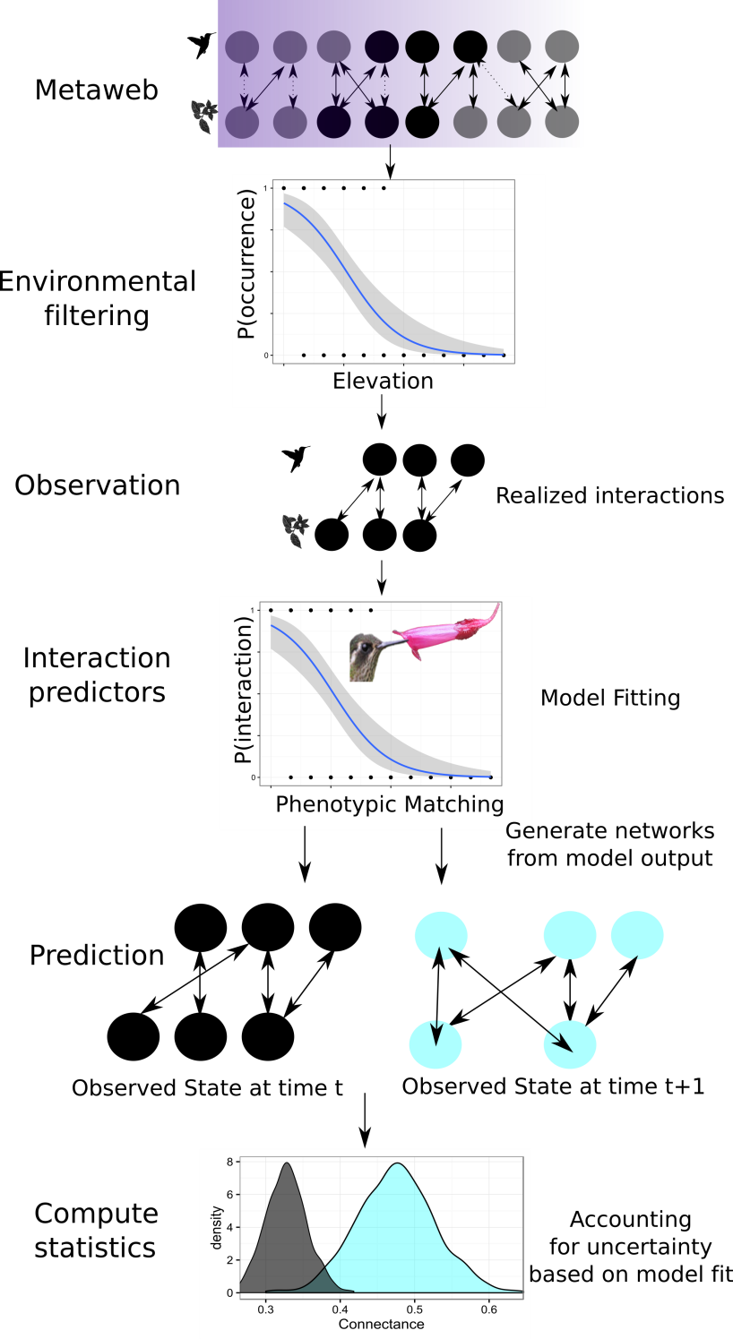Figure 1. Conceptual overview of the scaling of species interactions. Abiotic and biotic filter interactions from a meta-web into a set of realized interactions at the local scale. These local observations can be used to evaluate the importance of these filters and build predictive models of interaction strength. By comparing the fitted parameters from these models we can generate many realizations of interactions to calculate network statistics.

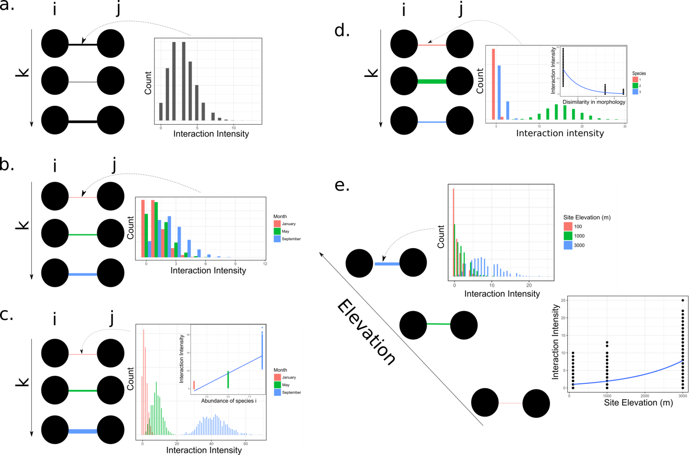

Figure 2. Frequency of interactions between species *i* and *j* for three different samples *k* where k is ecologically short time interval and difference interaction intensity is a function of a) stochastic variation in sampling, b) variation across months, c) temporal changes in species abundance, d) the dissimilarity in partner morphology, e) elevation dependent species abundance.

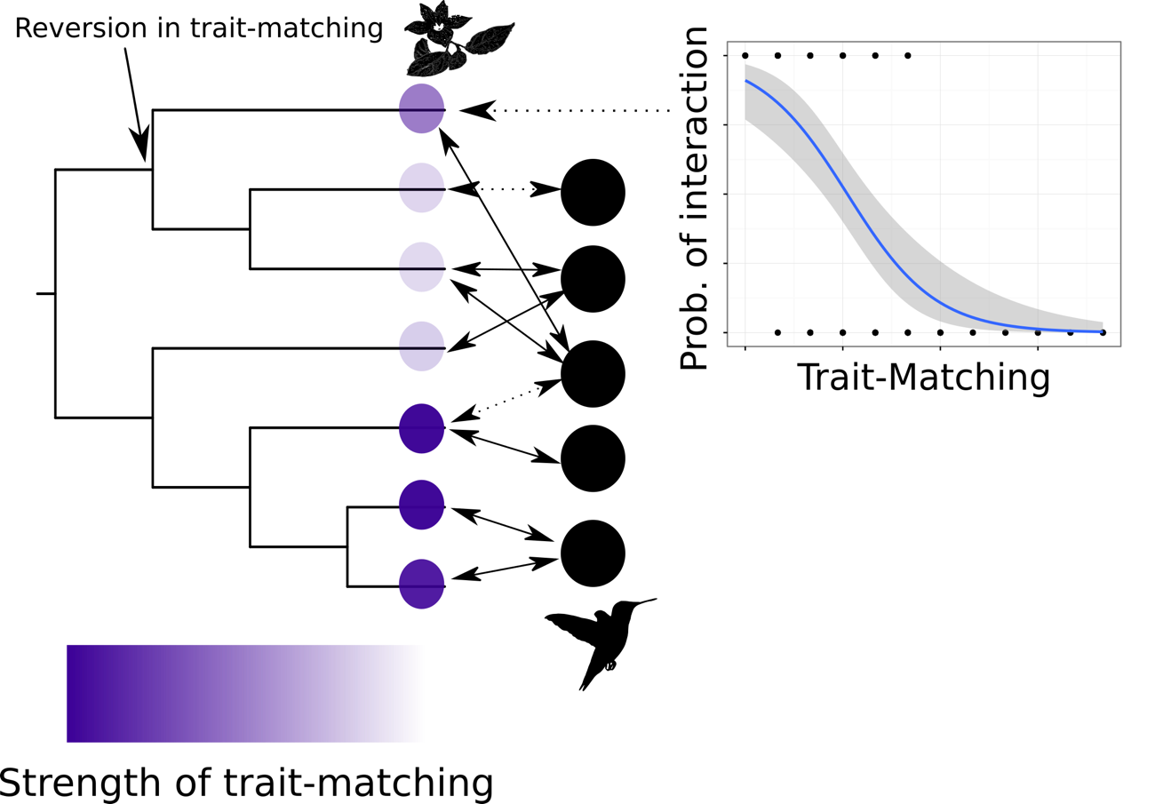

Figure 3. Mapping parameter estimates from local models of species interactions to community-level phylogenies. Here a hypothetical clade of co-occurring plants has strong trait-matching in one group, and weak trait-matching in another, with a reversion in trait matching for one species in the weak trait-matching group.

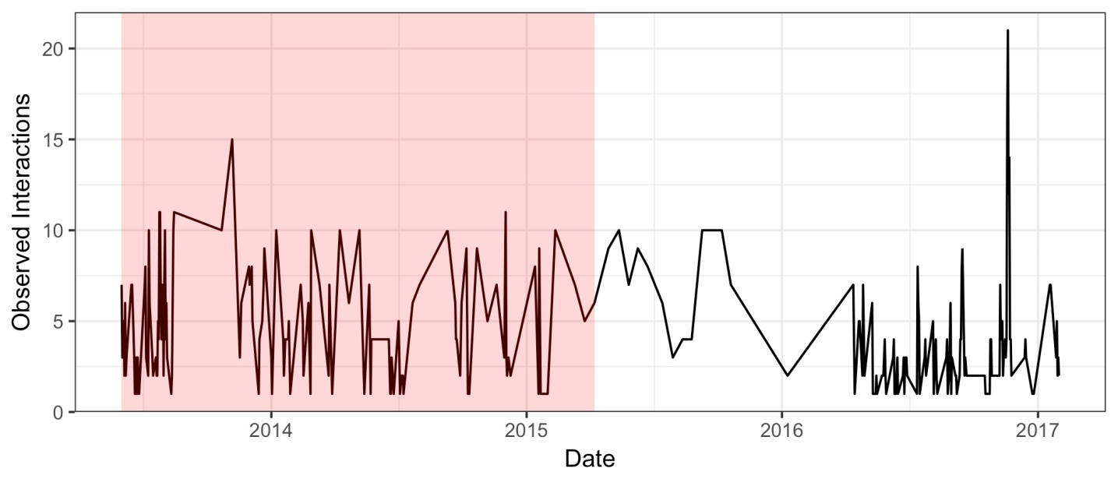Box 1. Figure 1. Time series of hummingbird-plant interactions from Northwest Ecuador. Time-lapse cameras were used to monitor interactions between 20 hummingbird species and 40 plant species. Each camera filmed individual plants from dawn to dusk for 2-5 days. The daily total number of observed links is between a hummingbird and flower is shown. The interactions in (n=597) in the red region were used to predict the interactions in the white region (n=451).

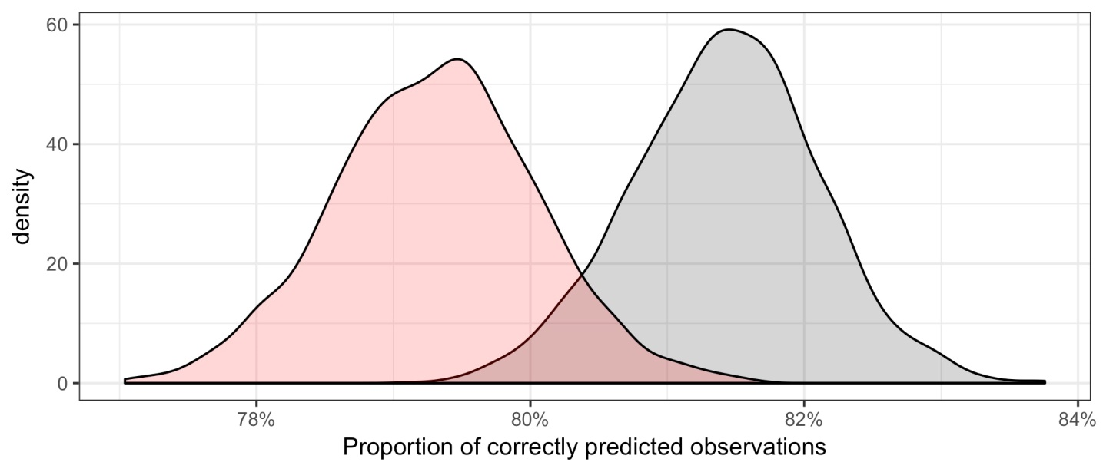Box 1. Figure 2. Prediction results of the binary trait-matching model for hummingbird-plant interactions. The proportion of correctly predicted observations when using the data from the 1st half of the time series (red) to predict the 2nd half of the time series. This is compared to the proportion of correctly predicted links when using data from the 2nd half of the time series to predict itself.

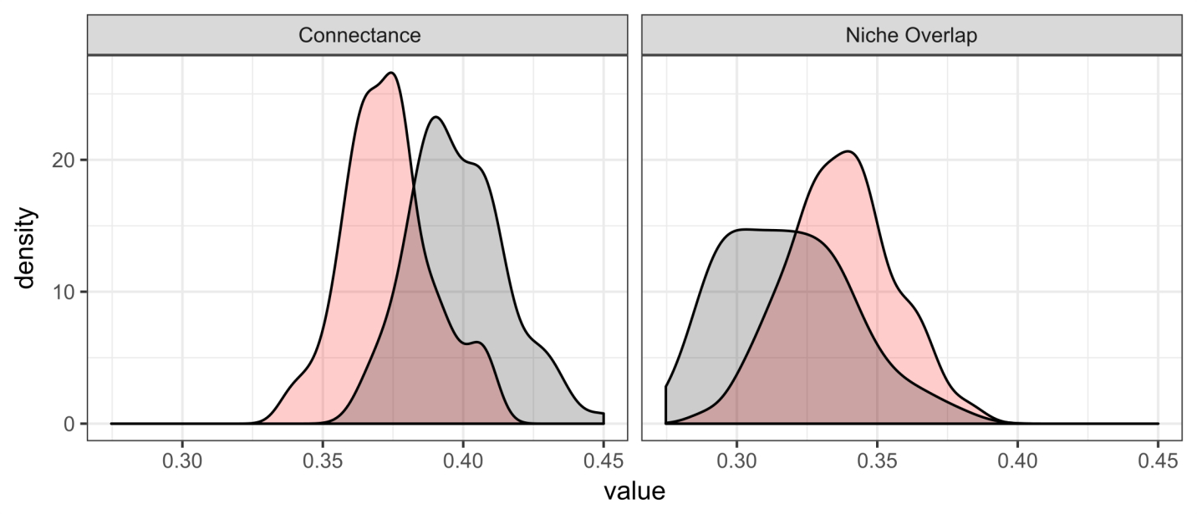Box 1. Figure 3. Network level results of the binary trait-matching model for hummingbird-plant interactions. One hundred networks were generated from the posterior distribution of fitted model parameters. For each draw, each link among species was a binomial draw based on the estimated probability of interaction due to trait matching. From each of these networks we calculated connectance and niche overlap of the lower level (plants). Network statistics from the predicted observations when using the data from the 1st half of the time series to predict the 2nd half of the time series (red) are compared to the network statistics when using data from the 2nd half of the time series to predict itself.